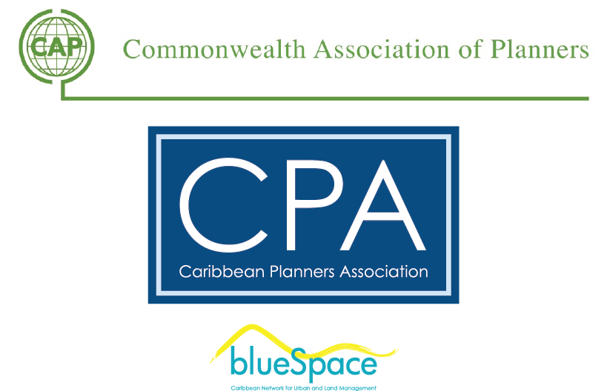

CAP Webinar Series:
'Planning for our children's, children, children’

Dear friend, you are invited to join us for the CAP Webinar Series.
Date: Thursday, September 3, 2015 from 4 to 5 PM GMT, 10-11 AM Belize, 12-1 PM Toronto, 7-8 PM Nairobi
Featured Presentation By:
Since TAYplan’s inception in 2009 Pam Ewen has been in charge of the Strategic Development Planning Authority for the Dundee and Perth City Region in Scotland. Within 3 years TAYplan won the Royal Town Planning Institute (RTPI) overall UK award for Excellence in Planning, the Silver Jubilee Cup. Pam is Convenor of RTPI in Scotland during 2015. Before moving to TAYplan she worked for 9 years as a planning manager with Fife Council leading strategic planning, economic policy, research and information, and the development of the 7 large strategic developments areas across Fife. After graduating in the early 1990’s from Strathclyde University she commenced her career in Local Government in Ayr before moving to Central Region and then Clackmannanshire working across development management, project implementation and development planning. Pam has a degree in Town Planning and an MBA. She is a member of the RTPI, member of Heads of Planning Scotland Executive and is a Board member of the Scottish Cities Knowledge Centre. Pam is moving to Fife Council in late September to head up planning.
The presentation ’Planning for our children’s, children’s, children’ will set out the importance of involving young people in how they can shape the future of their places. Pam will explore the different ways in which TAYplan has engaged with young people and the success this has had. The presentation is intended to share good practice and to stimulate some discussion with young planners across the Commonwealth and other areas of good practice.
For more information, visit the CAP Young Planners Blog website at: https://capyoungplanners.wordpress.com/

Registration: Please email Viral Desai at viral.desai.cap@outlook.com to register for the event. We hope you can make it!
Best Regards.
This Commonwealth Association of Planners Webinar Series event is brought to you by the Caribbean Planners Association with the support of the Caribbean Network for Urban and Land Management "blueSpace" and UN-Habitat.

